**9 May 2024**

**PRESS RELEASE**

**Vanizem™ rapidly enhances mental wellbeing and sleep quality, new study shows**

Nektium’s new Vanizem™ botanical extract can significantly improve mood, reduce stress levels and enhance sleep quality within just three days, a pilot study has found.

Created from the West African spice *Aframomum melegueta*, the ingredient can be used to create mood-boosting supplements and other products without any sedative effects.

The placebo-controlled crossover study, which is expected to be published in a scientific journal in mid-2024, featured 30 men and women aged between 40 and 50. The researchers used a number of standard clinical measures to determine how Vanizem™ impacted their mental wellbeing and sleep.

The 30 participants were otherwise healthy adults experiencing day-to-day stress and anxious feelings, as measured by the Hamilton Anxiety Scale (HAM-A). All those consuming a dosage of at least 100mg significantly reduced their HAM-A scores below the threshold for anxiety by the end of the pilot study.

The Profile of Mood States (POMs) measure was used to assess changes in tension, depression, vigor, and fatigue. After three days of supplementation with a 150mg dose, self-reported perceptions of tension reduced by 19%, fatigue reduced by 23%, depression reduced by 34% and vigor improved by 8%. Total mood disturbance (TMD) scores, which are used to assess overall mood state, improved by 54% with a 100mg dosage and 77% with a 150mg dosage.

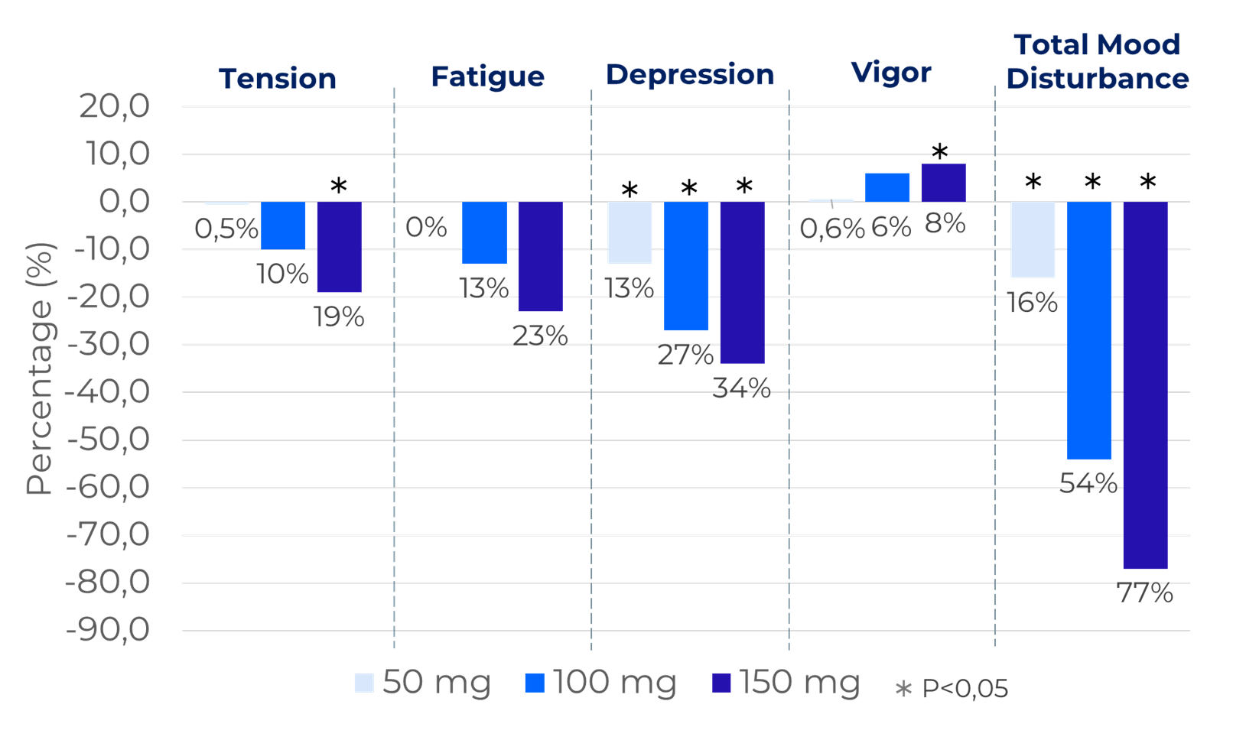

*Figure: Results of the POMs questionnaire. The results show the percentage of improvement for each dose versus placebo after three days of ingesting Vanizem™*

Participants also took part in the Leeds Sleep Evaluation Questionnaire (LSEQ), which determines sleep quality based on self-reported ratings. Vanizem™ was shown to be fast-acting, with doses over 100mg improving sleep quality scores after the initial dose. After three days, ratings improved by more than 30% versus placebo.

Throughout the pilot study, Vanizem™ was found to be safe and well tolerated by all participants, with no adverse side effects reported, demonstrating its suitability for daily use.

Bruno Berheide, Nektium’s Commercial and Partnership Director, said: “In today's fast-paced world, managing mental health and stress has become more critical than ever. Vanizem™ is a fast-acting botanical extract that can help consumers unlock their inner calm. Unlike many mood enhancers and stress relief options, it is also a non-sedative solution so does not cause any drowsiness while carrying out everyday activities.”

Vanizem™ is produced from a sustained, cultivated source of *Aframomum melegueta*. Its main bioactives are three vanilloids: 6-shogaol, 6-paradol and 6-gingerol.

In addition to the pilot study, Nektium has carried out in vitro research on Vanizem™ that is due for publication in mid-2024. This has enabled the company to demonstrate for the first time that *Aframomum melegueta* targets the endocannabinoid system, which is a key regulator of stress and emotional responses. Vanizem™ inhibits the fatty acid amide hydrolase (FAAH) within the endocannabinoid system and maintains levels of anandamide – also known as the “bliss molecule.”

The in vitro research also shows Vanizem™ has an effect on the TRPV1 receptor, which is the specific receptor for vanilloid compounds and is known to mediate pain perception, inflammation and body temperature. Furthermore, the in vitro results indicate that it could activate 5-HT1A, a critical component in serotonin pathway modulation, and CB2R, which plays a key role in reducing neuroinflammation in response to stress. The findings underline the potential for Vanizem™ to positively influence mood regulation and feelings of anxiety in healthy adults.

To create the ingredient, Nektium uses a gentle and natural extraction process that helps to maintain the potency of the bioactive compounds in the *Aframomum melegueta*. The company’s proprietary microencapsulation technology is also used to enhance the extract’s stability and efficacy.

Nektium’s Head of Product, Laura López, said: “Our sophisticated formulation approach not only protects the active compounds from degradation but ensures that Vanizem™ retains its potency over time. With the recommended dosage of just 100mg to 150mg per day, it provides a simple solution that enables consumers to reliably lower tension and enhance feelings of calmness.”

**Nektium will offer Vanizem™ samples in capsule format at Vitafoods Europe 2024 (14-16 May, Geneva).** **The company will also present a talk at the show entitled “New natural alternative for stress relief and mood-boosting” in the New Ingredients Theatre (F184) at 1.30pm on 15 May.**

**ENDS**

**For more information please contact:**

Robin Hackett, Ingredient Communications

Tel: +44 (0) 7507 277733 | Email: [robin@ingredientcommunications.com](mailto:robin@ingredientcommunications.com)

**About Nektium**

Based on the island of Gran Canaria, Spain, Nektium specialises in the supply of branded and generic botanical ingredients of the highest quality. The business was born out of two friends’ shared passion for the phytochemistry and pharmacology of botanicals and their applications in health and wellness. When it was first established in 1997, little was known about many of these botanical extracts, but the team at Nektium made it their mission to explore and unleash their potential health benefits. Today, the company is still defined by this solid foundation of dedicated relationships and its love for nature and research. Nektium’s flagship products are Zynamite®, a proprietary mango leaf extract (*Mangifera indica*), Rhodiolife®, a rhodiola plant extract (*Rhodiola rosea*) as well as Xanthigen®, a proprietary botanical blend for weight management.